

***Course Code:* CSE479**

***Section* - 01**

***Semester – Summer 2025***

*Submitted To:*

Nishat Tasnim Niloy

Lecturer

Department of Computer Science and

Engineering,

East West University

*Submitted By:* Group 01

|  |  |
| --- | --- |
| Rafsun Islam Taskin | 2021-3-60-024 |
| Tasmiah Rahman Orpa | 2021-3-60-021 |
| Shaila Afroz Anika | 2021-3-60-045 |
| B. M. Shahria Alam | 2021-3-60-016 |
| Md. Mahir Faysal | 2022-1-60-041 |

# Introduction

# QuizWave is an interactive quiz management platform designed to enhance digital learning and assessment. It provides teachers with powerful tools to create and host quizzes, manage questions, and grade student attempts, while offering students an engaging environment to join, attempt, and review quizzes in real time.

# Built on Supabase for robust authentication, efficient data management, and real-time interactivity, and crafted with a streamlined HTML, CSS, and JavaScript frontend, QuizWave delivers a smooth, secure, and intuitive user experience. Guided by the principle *“Learn. Compete. Grow.”*, the platform not only evaluates knowledge but also fosters collaboration, competition, and active participation in education.

# Functional Requirements

# *Functions for Teachers:*

# Design, edit, and manage quizzes and question banks with flexibility.

# Host live quizzes that enable real-time student participation.

# Review and manually grade pending quiz attempts.

# Access leaderboards and detailed performance analytics to track progress.

# *Functions for Students:*

# Register, log in, and maintain a personal profile.

# Join quizzes seamlessly using session codes.

# Attempt quizzes under monitored, timed conditions.

# Submit answers and instantly view results and feedback.

# *System Functions:*

# Provide secure authentication and role-based authorization for teachers and students.

# Enable realtime communication channels to support live sessions.

# Ensure reliable storage and retrieval of quizzes, user data, and results.

# System Diagrams:

## Use Case Diagram:

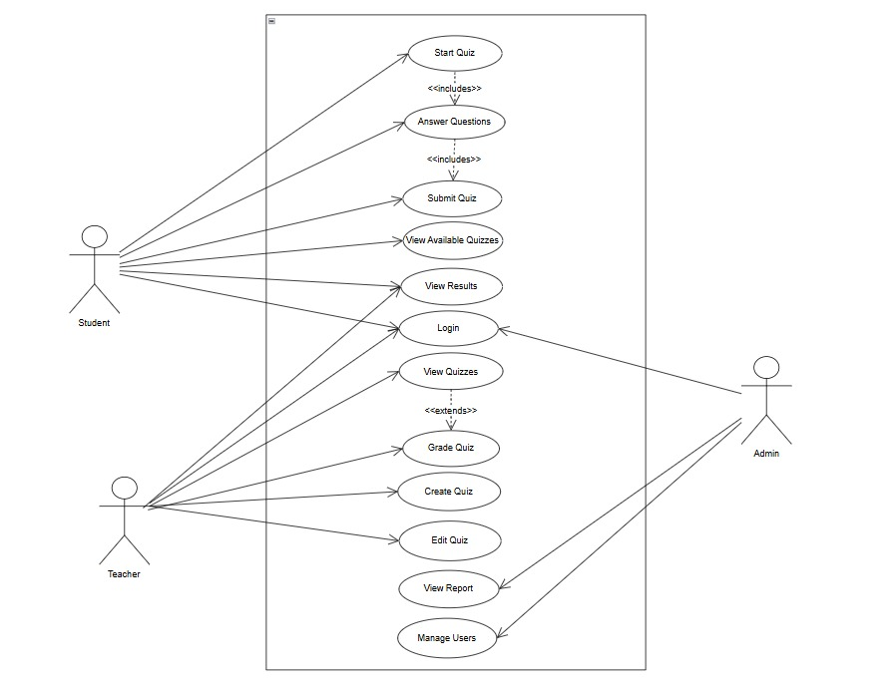

## Activity Diagram:

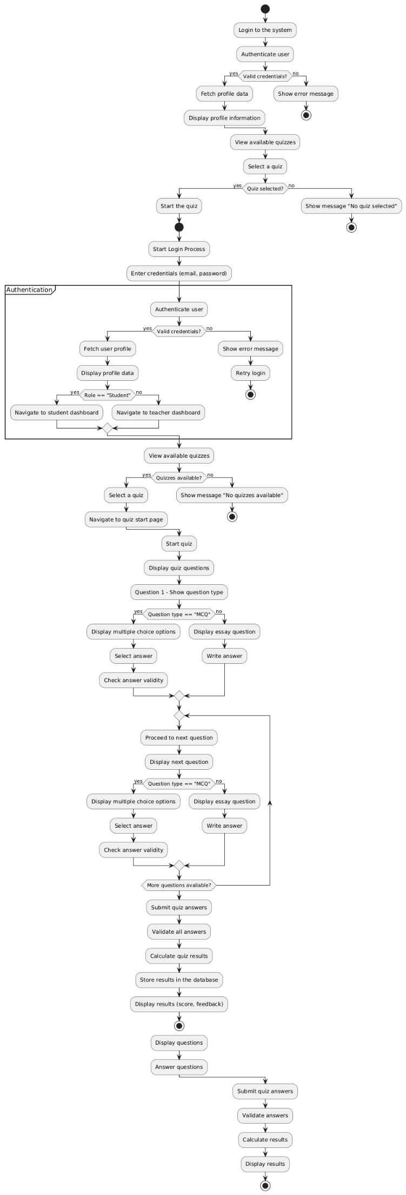

1. **Sequence Diagram:**

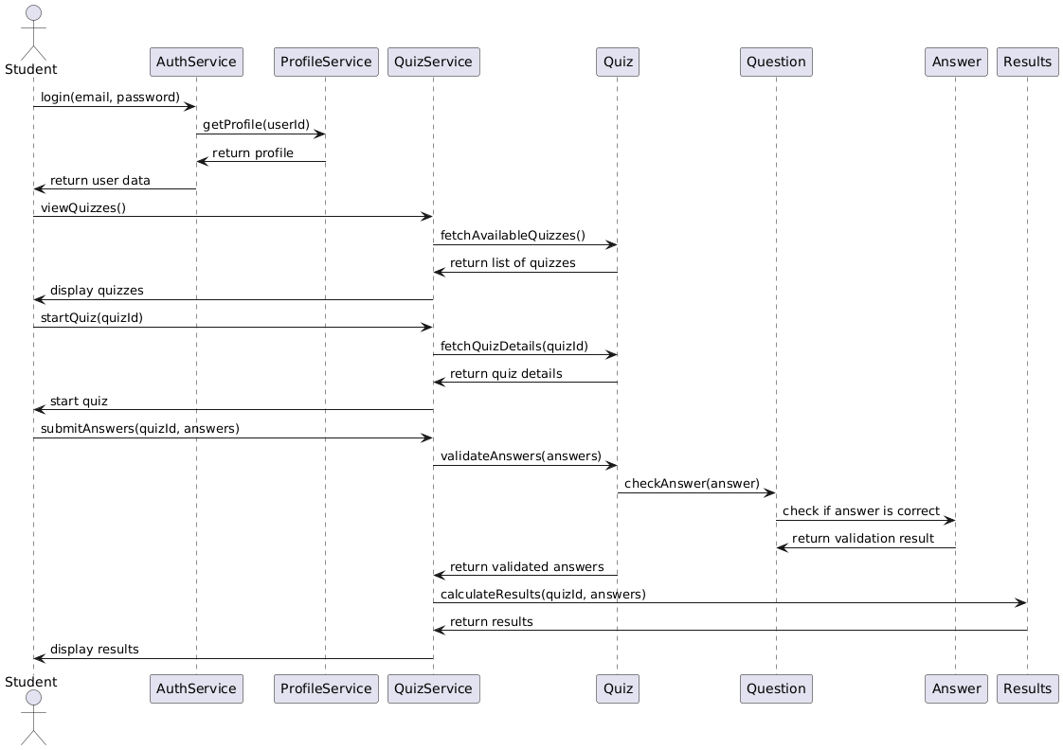

1. **Class Diagram:**

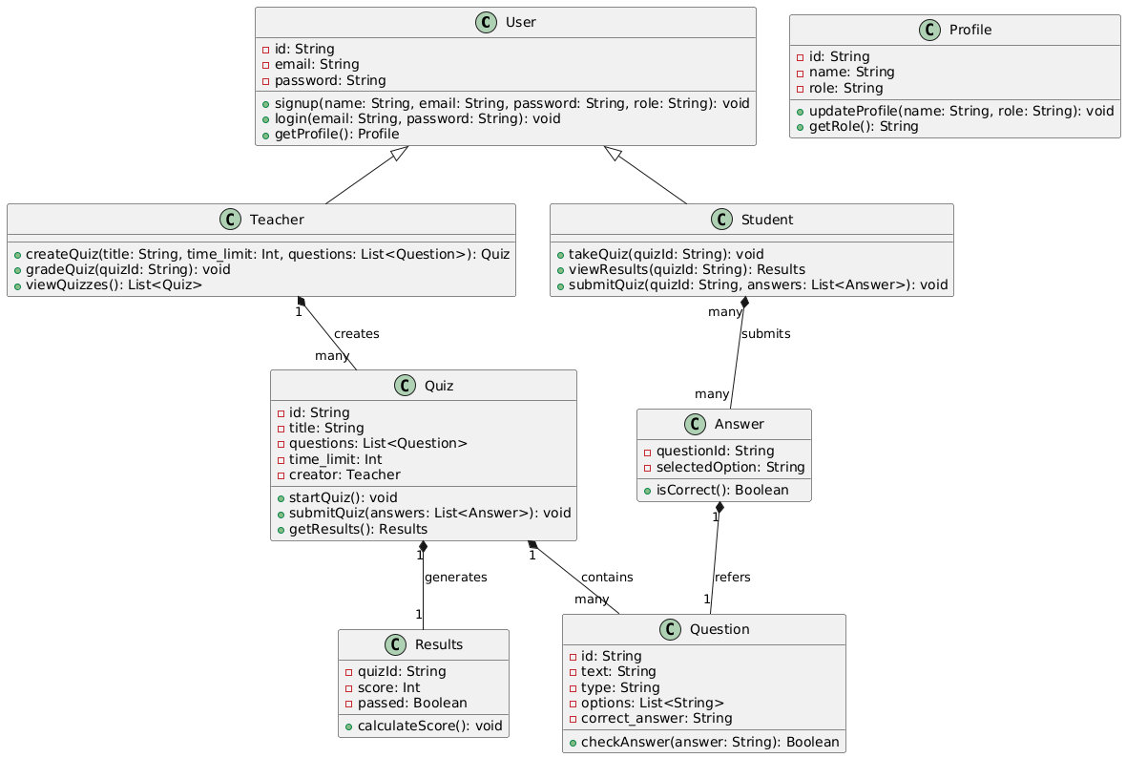

# Technology Details

* **Frontend**: HTML, CSS, Vanilla JavaScript (21 modular scripts).
* **Backend**: Supabase (for Auth, Database, Storage, Realtime channels).
* **Architecture**: Multi-page application; teacher, student, and admin dashboards separated.
* **Database**: Supabase tables for users, quizzes, questions, attempts, results, and leaderboards.

# Screenshots of the project:

**Home page:**

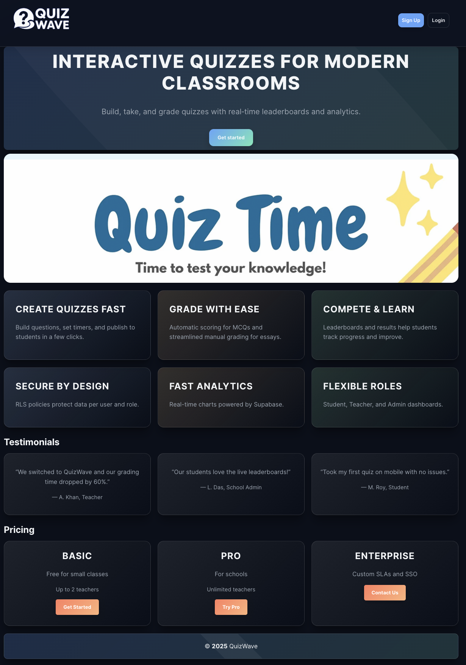

**Signup page:**

**Login page:**

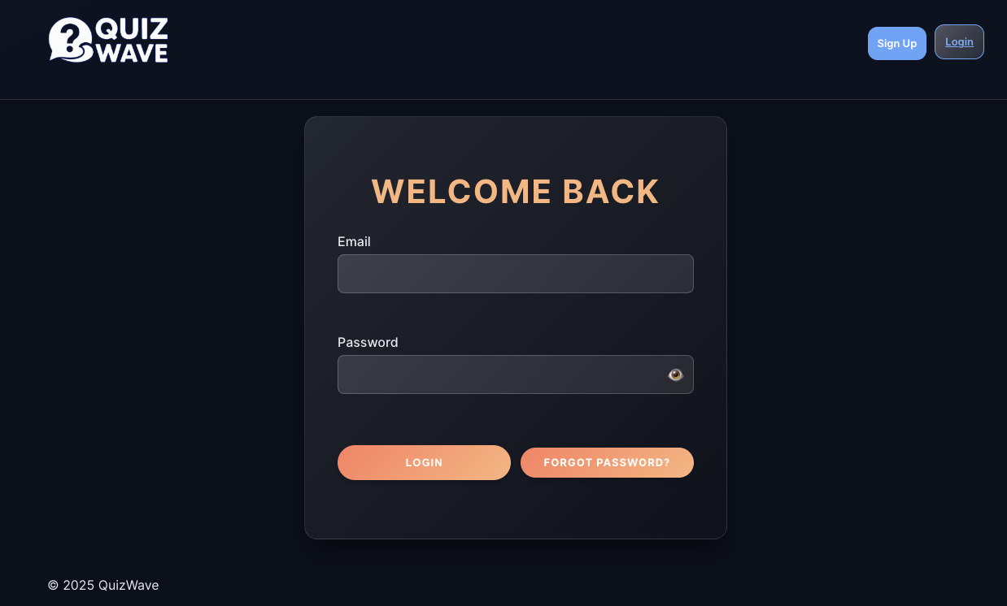

**Admin Dashboard:**

**Admin Profile:**

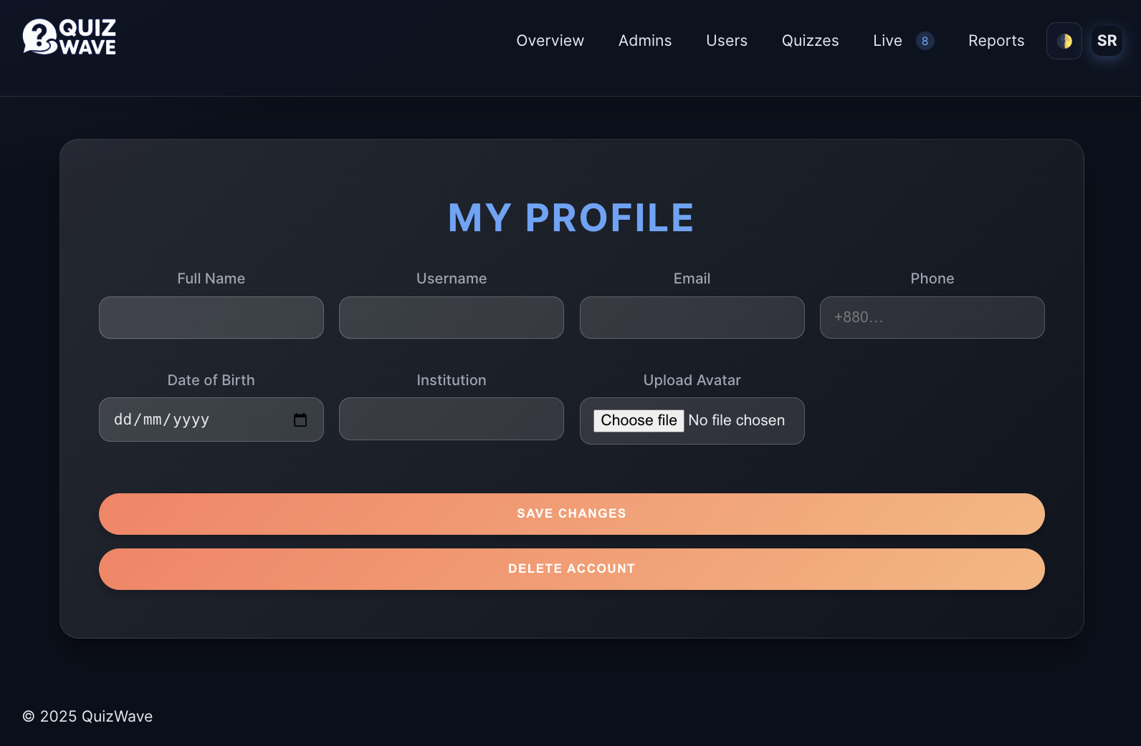

**Teachers Dashboard:**

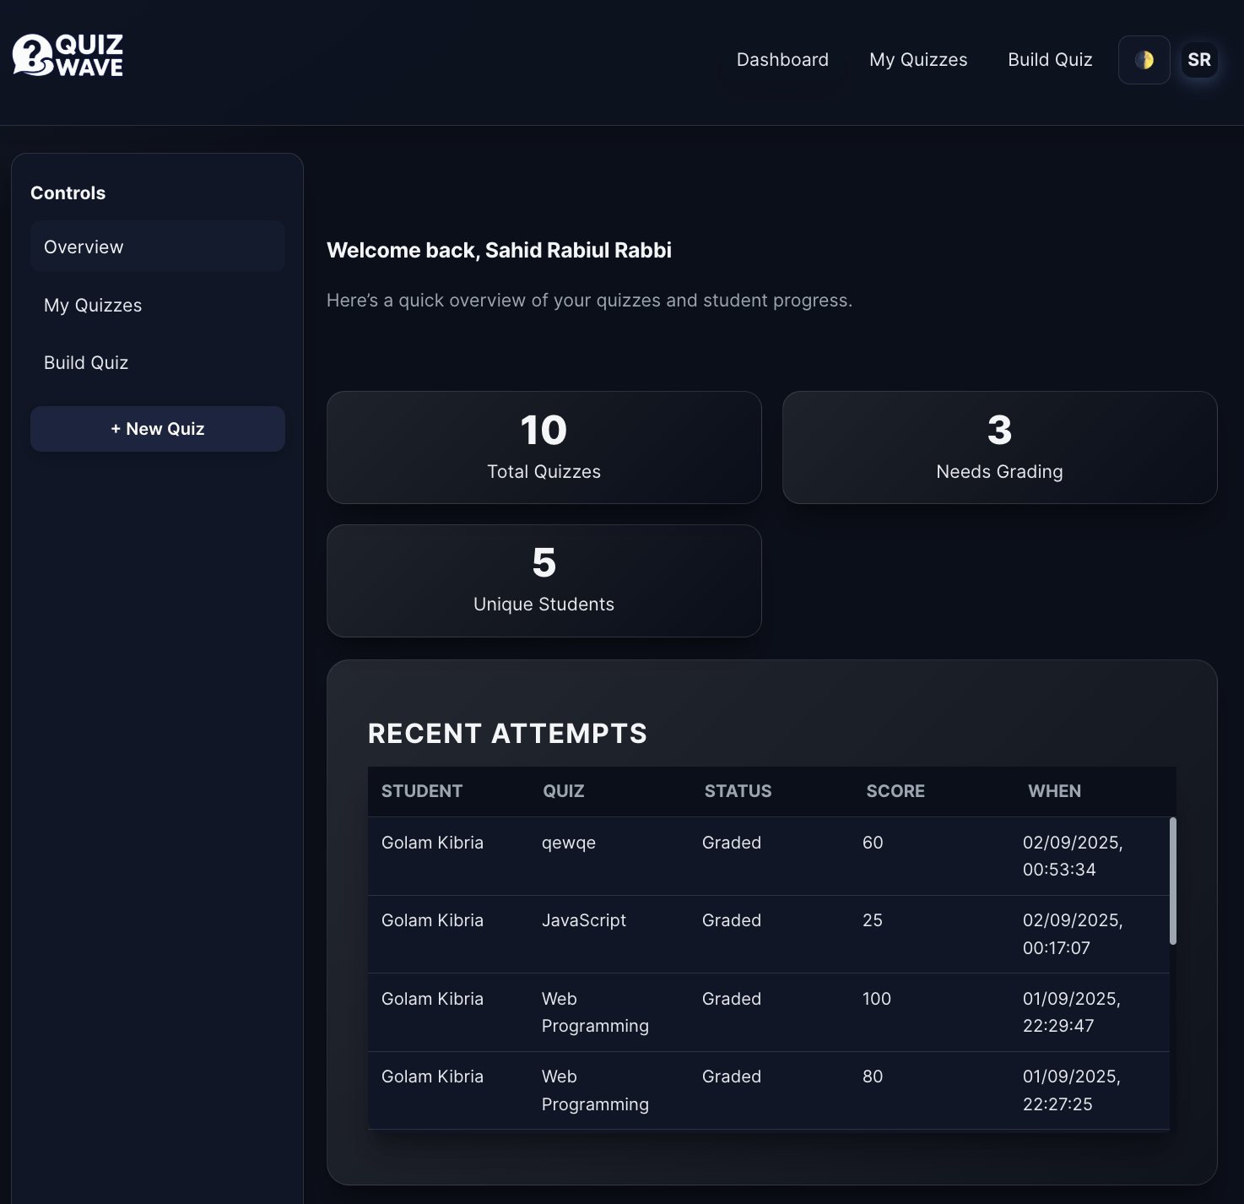

**Teacher (Create quiz page):**

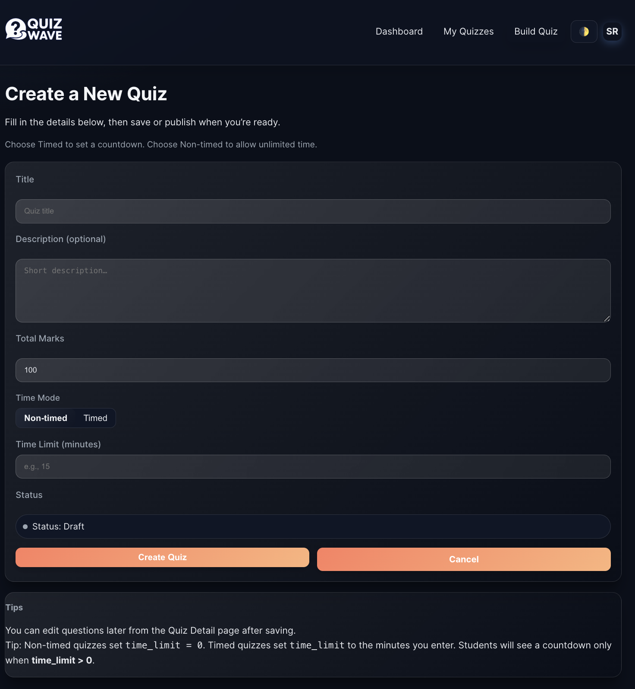

**Teacher (All quiz):**

**Student Home Page:**

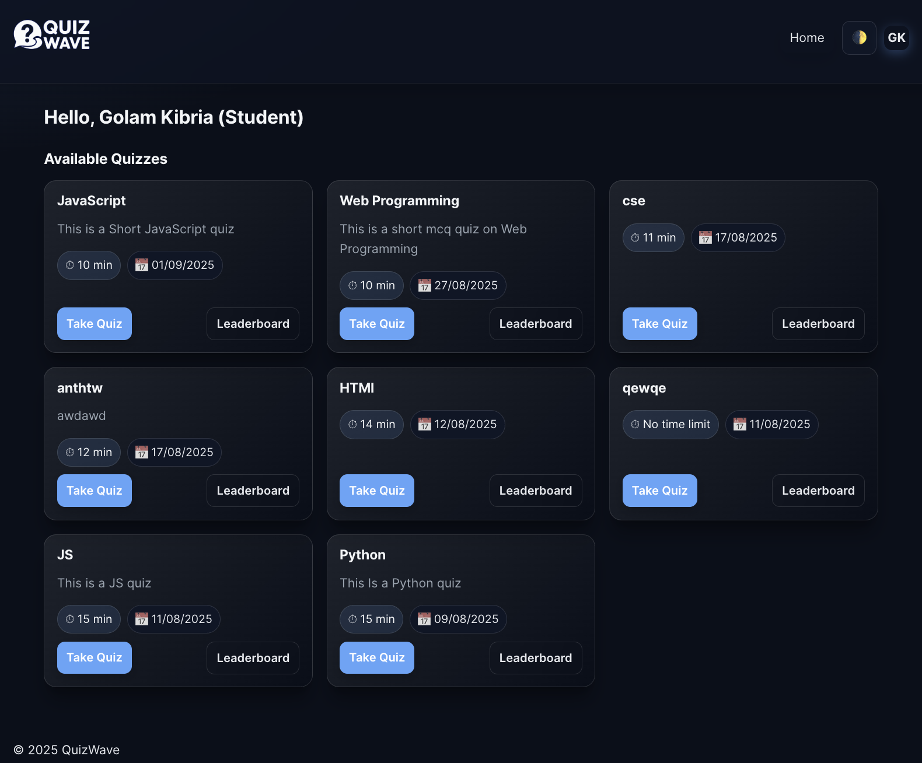

**Student (Quiz Leader Board):**

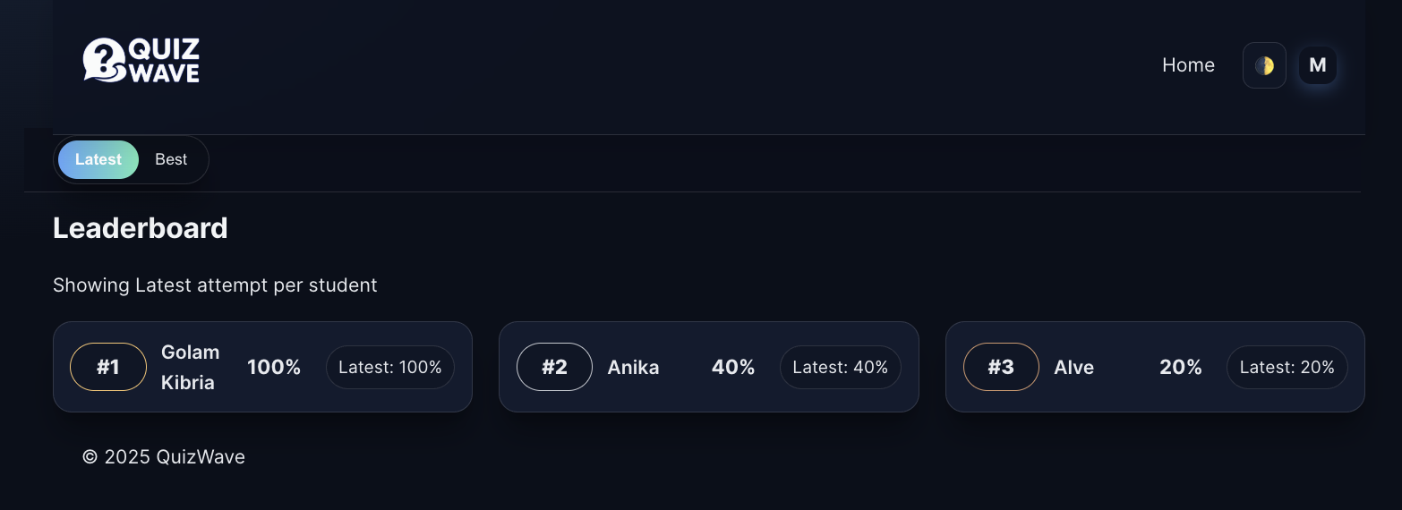

# Team Responsibilities

## The successful development of QuizWave was made possible through the collaborative efforts of the project team. Each member contributed their expertise in distinct areas:

## Rafsun Islam Taskin (Backend Developer) Responsible for integrating Supabase services, including authentication, database schema design, data management, and realtime features to ensure a secure and reliable backend system.

## MD Mahir & B. M. Shahria Alam (Frontend & Designer) Focused on designing and developing the user interface using HTML, CSS, and JavaScript. They ensured a responsive, intuitive, and user-friendly experience for both teachers and students.

## Shaila Afroz Anika (System Designer) Designed the system diagrams, including use case, activity, and sequence diagrams, providing a clear blueprint of the system’s structure and workflows.

## Tasmiah Rahman Orpa (Project Documentation Lead) Compiled and structured the project documentation, ensuring that all aspects of the project were clearly presented, professionally formatted, and aligned with academic standards.

# Conclusion

**QuizWave** successfully fulfills its vision of creating an engaging, interactive, and real-time quiz platform. It empowers teachers with efficient tools for assessment and provides students with a dynamic, timed environment that enhances participation and learning outcomes.